SmartSat CRC is hosting it’s inaugural Participants Conference. This event is an opportunity to bring our research and industry partners together to:

- Review the initial two years research projects
- Discuss SmartSat’s Strategic Directions
- Meet the SmartSat team, including CEO and Chief Research Officer
- Interact and connect to create new partnerships
NOVEMBER

18-19
2022
ONLINE

THURSDAY 18 NOV
Future of Industry
FRIDAY 19 NOV
SmartSat Showcase

9:00
9:30
10:00
10:30
11:00
11:30
12:00
12:30
13:00
13:30
14:00
14:30
15:00
15:30
16:00
16:30

Lunch

Aurora Town Hall
Break

Distinguished Speaker
Welcome & Introductions
Lunch

Space Technologies for Autonomy, Constellations & Remote Sensing
Break
SmartSat Strategic Direction:
Driving innovation and transformation

SmartSat Research Framework:
Technology Pathways to Capability Demonstrators
Welcome & Introductions

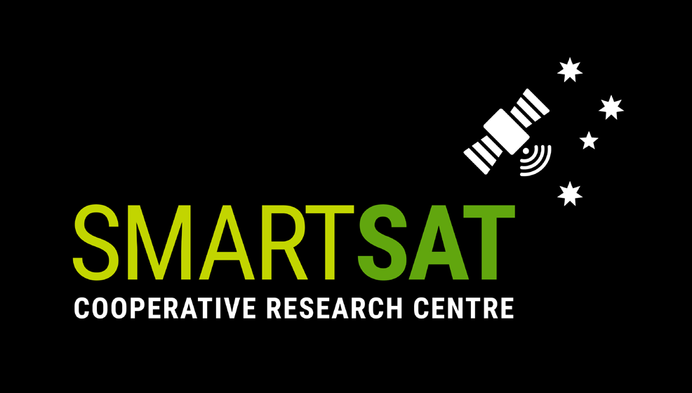CONFERENCE AT A GLANCE
Wrap Up

SmartSat Horizon through partner engagement

PhD Professional Development Session
Break

PhD’s Project Presentation

Harnessing Earth Observation for the future of Australia
Break

Next Generation Space Communication & Connectivity
All times are presented in Adelaide Time (ACDT)

*Program subject to change

